EasyToll – Toll Payment System
Project: EasyToll | Technology: HTML, CSS, JavaScript (localStorage)

Aim
To develop an electronic toll system with wallet payment, tickets, passes with QR codes and gate verification.

Algorithm
- Start: load users, gates, passes and transactions.
- User registers/logs in and adds money to wallet.
- Buy a toll ticket or apply for a pass; admin approves the pass.
- Pass is shown as a QR code.
- Gate operator verifies QR/pass at the gate; toll is charged if no valid pass.
- Wallet balance is reduced; transaction saved.
- Admin manages gates, operators and users. Stop.

Result
The EasyToll – Toll Payment System was implemented successfully using HTML, CSS and JavaScript. All modules (login, role-based pages, data entry, search/booking and admin management) work correctly in the browser, and data persists using localStorage.

Implementation (Output Screenshots)
Home page
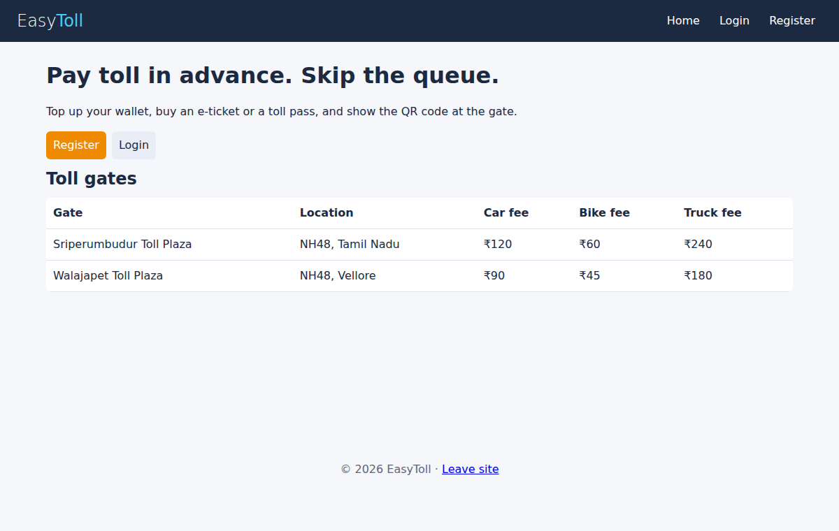
After login (admin / dashboard)
